To add recipients, click Select the recipients or type the email addresses separated by semi-colons.
Example of entered email addresses:
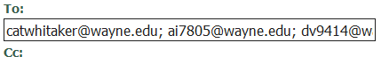
Or you can add recipients using the steps below:
- Select the recipients… 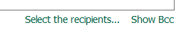
- Select ‘WSU_LDAP’ link 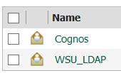
- Select the ‘Search’ link in the far upper right hand corner 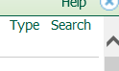
- Type in the accessid to be added (lowercase) and select Search
- When the accessid is found, check the box next to the id and select the yellow arrow to add to entries and then hit ok.
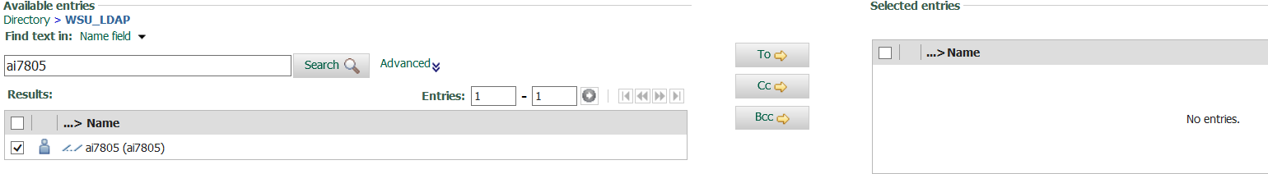
- Select ok and the user will added to the distribution list.

