- Select Set properties icon
- Select Permissions tab 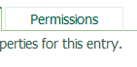
- Select Add
- Select ‘WSU_LDAP’ link 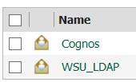
- Select the ‘Search’ link in the far upper right hand corner 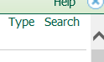
- Enter the accessid to be added (lowercase) and select Search
- When the accessid is found, check the box next to the id and select the yellow arrow to add to entries and then hit ok.
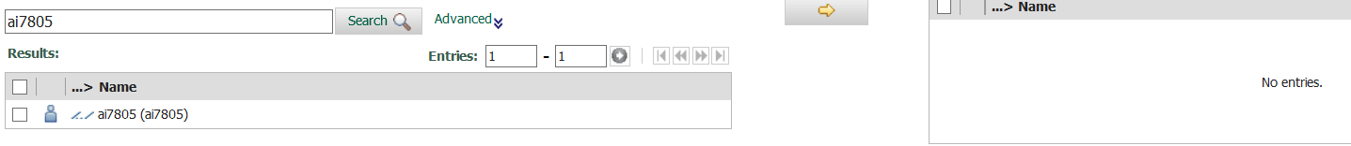
- The accessid will be in the list of Names, check the box next to the accessid added and select the appropriate permissions. Always give ‘Read, Execute and Traverse to all users. 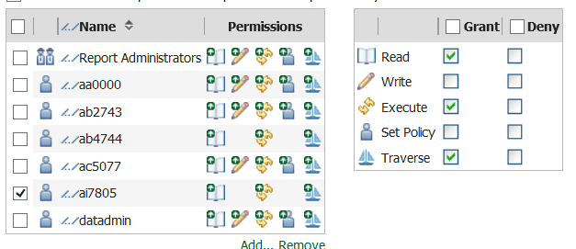
- Select ok and the user will have access to the folder.

